**Azure Containers/Kubernetes**

* Containerization with Docker and Kubernetes in Azure
* Architecture of Docker (Docker Daemon, Docker Client, Docker Host, Docker Registry, Docker Images, Docker Containers, Docker Storage)
* Azure Container Services (Instances, Apps), Azure Kubernetes Services
* Azure Container Registry
* Kubernetes is an open-source Container Management tool that automates container deployment, container scaling. It is written in Golang and manages Docker containers in form of clusters.
* Automated Rollouts and Rollbacks in Kubernetes
* Architecture of Kubernetes

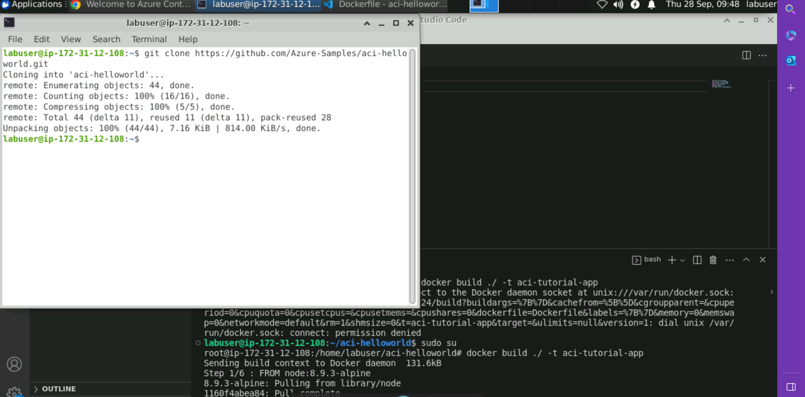

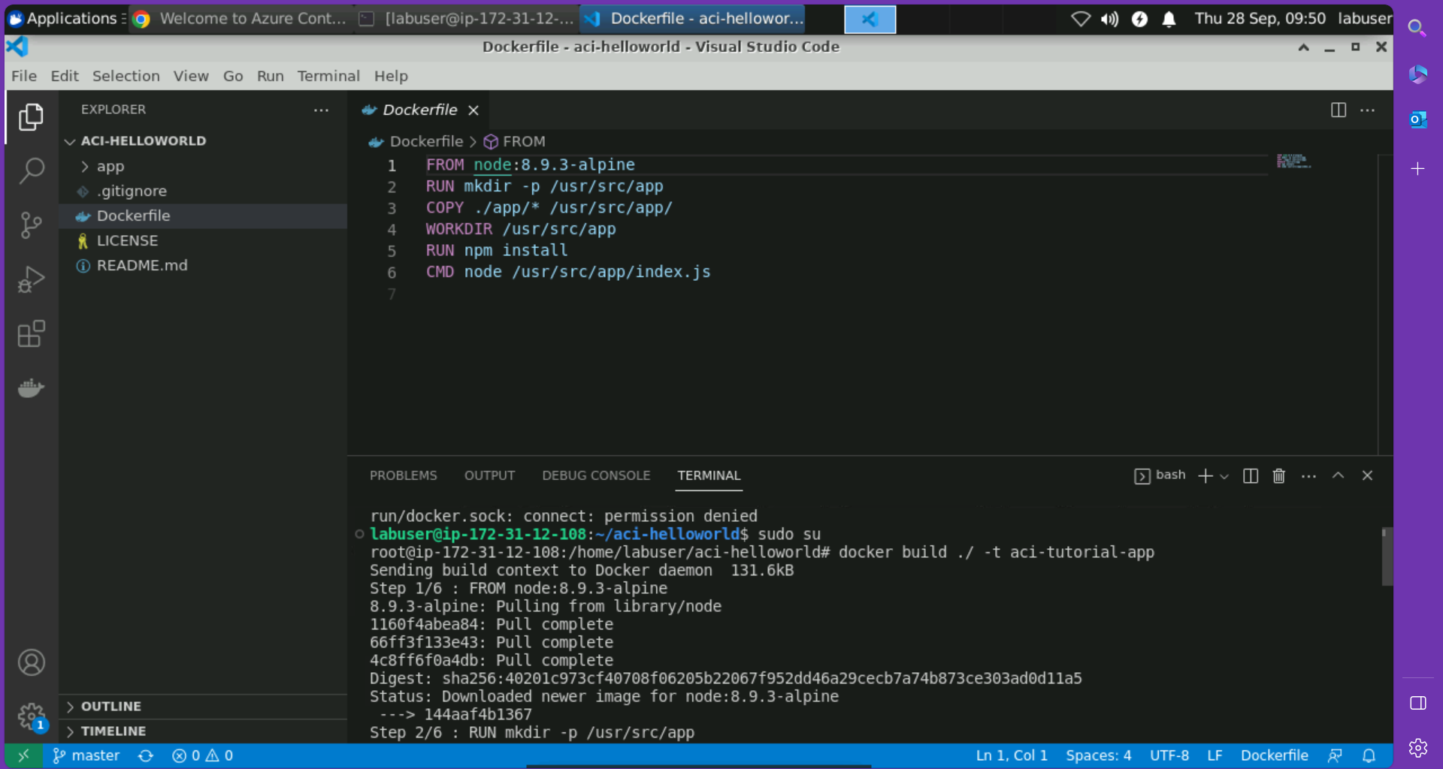

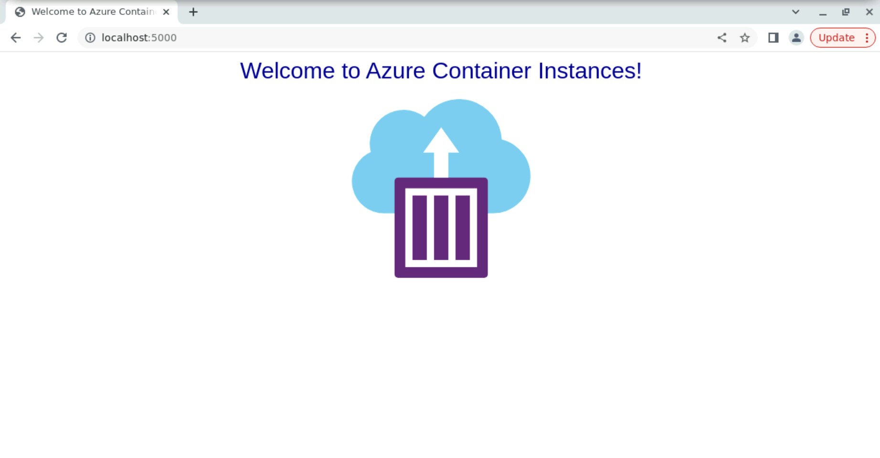

Features of Kubernetes:

* Automatic Scheduling
* Self-healing capabilities
* Automatic Rollouts and Rollbacks
* Resource Utilization
* Support for multiple clouds and hybrid clouds
* Extensibility
* Community Support

Architecture of Kubernetes Services

- Client server architecture: master installed on one machine and the node on a separate Linux machines.

- Master slave model: master to manage docker containers across multiple Kubernetes code